Technical specifications

Product Name: | Multi-channel photovoltaic module steady-state test system
Product Model: | MCT10-300-20T

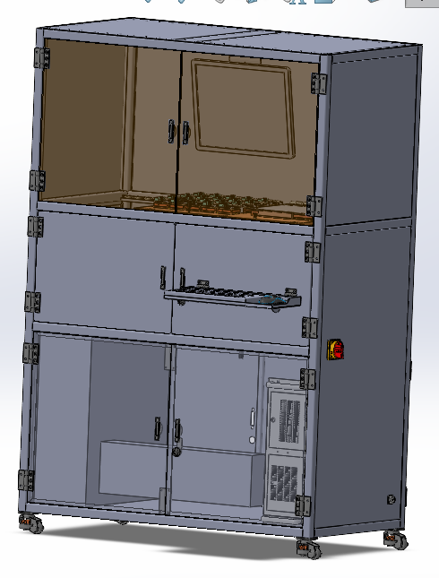

Lecheng Intelligent Technology (Suzhou) Co., Ltd
December 2024

directory
1. Equipment overview 3
2. Test object 3
3. Specification summary 3
1. Technical parameters 3
2. Equipment structure 3
3. Main components of the equipment 4
4. Main component functions 4
1. Steady-state light source 4
2. Multi-channel electrical test cells 6
3. Multi-channel temperature control and monitoring module 6
4. Software testing systems 7
5. other 8
5. Factory business needs 8
6. Annex related 8
1. Documentation 8
2. Amenities 8
3. Consumables 9
7. Service description 9
1. Installation and commissioning 9
2. After-sales training 9
3. Equipment maintenance 9

Equipment Overview:
MCT series equipment is a standard solar simulator that irradiates multiple perovskite photovoltaic modules at the same time, controls the temperature of each photovoltaic module separately through multiple channels, and collects the I-V performance parameters of each module and the MPPT maximum power point tracking data at the same time, so as to achieve high-throughput testing of the temperature stability and light operation stability of photovoltaic modules, providing convenience for the development of perovskite materials and process reliability screening.
The equipment is efficiently integrated, integrating LED steady-state simulator light source, multi-channel test base, switching platform, multi-channel temperature control and monitoring module, multi-channel test source table and load, data acquisition display automatic storage system, etc., which can achieve high throughput, independent non-interference of each module, long-term automatic test of high temperature and light operation performance degradation data of batteries and modules.

Test objects
The test objects are thin-film solar cells and modules, and the substrate is glass or flexible materials, and the specific specifications are as follows.
project | numeric value
Material | Glass substrates or flexible substrates thin-film solar cells and modules
thickness | 1mm—8.0mm
Test sample size | 50*50mm, 158*158mm, 220*220mm, 300*300mm package components, positive and negative lead wires

Specification overview

Technical parameters
Model | MCT10-300-20T
Adapts to product size | 50*50mm、158*158mm、220*220mm、300*300mm
Device size | 1200×800×1800mm

Equipment structure
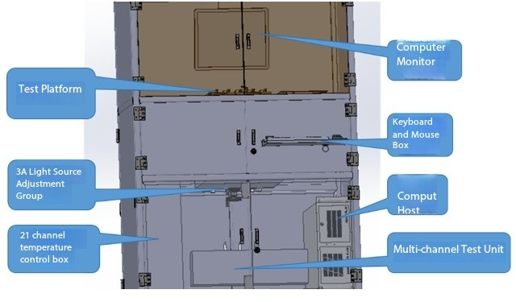 The equipment is composed of light source module, test platform, multi-channel test unit, temperature control module and control software. The light source is a down-lit structure, and the height of the test platform is controlled by the lifting module, and the test platform can be moved left and right to switch between multi-channel test and single large component test mode.

Main components of the equipment
serial number | fittings | quantity | remark
1 | Class 3A LED steady-state solar simulator | 1 set | 100*100、220*220、300*300mm
2 | Multi-channel electrical test cells | 1 set | 1-channel/20-channel switching, 4-20 channels can be customized
3 | Multi-channel temperature control and monitoring module | 1 set | 1-channel/20-channel switching, 4-20 channels can be customized
4 | Multi-channel I-V, MPPT data acquisition, automatic monitoring data storage software system | 1 set | The interface and functions can be customized according to your needs

Main component functions

Steady-state light source
The light source adopts a 3A LED steady-state solar simulator.
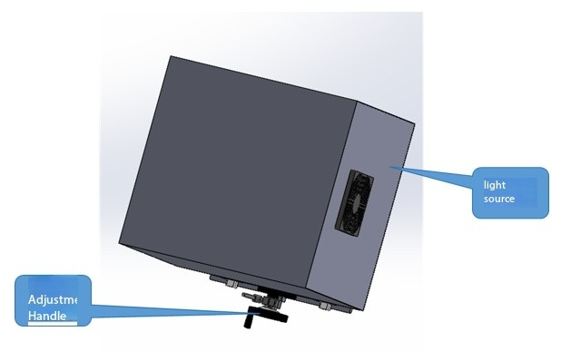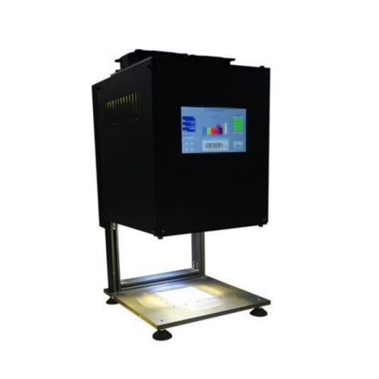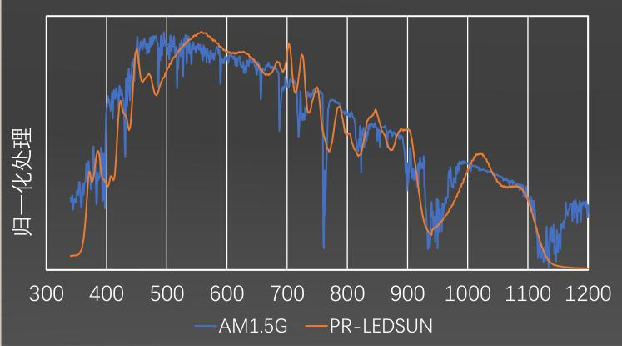

Model | LED-3A-100 | LED-3A-220 | LED-3A-300
Light source category | LED steady-state light source
Light source life | 10000h
Effective area | 100*100mm | 220*220mm | 300*300mm
Spectral wavelength range | 350-1100nm、300-1100nm、350-1200nm、300-1200nm可选
Power adjustment range | 100-1100 W/m2 adjustable
Spacing adjustable range | 10-40cm, accuracy 0.1cm
Spectral match | A/A+（AM1.5G）
Time instability | A≤±2%
Spot uniformity | A≤2%
Supply voltage | Power Supply: AC 220V/50HZ

Multi-channel electrical test cells
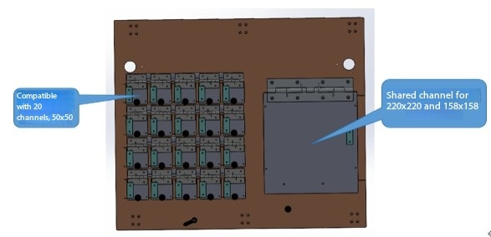
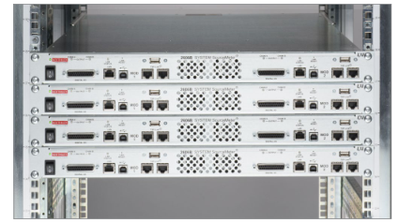
The multi-channel electrical test unit can test 20 channels at the same time, the component size is basically 50*50mm, and other size specifications can be customized. At the same time, the test platform can be directly switched to a single channel of large modules, which is compatible with various types of crystalline silicon modules 156/182/210mm and corresponding encapsulated crystalline silicon/perovskite stacked modules. The electrical parameters are as follows:
Model | Multi-channel (perovskite or stacked) DC-PS/PT | Single channel (crystalline silicon or stackup)  SC-SS/PT | Single-channel perovskites  SC-PS
Multi-channel test base | 4/8/20 channels within 50mm | 156/182/210mm | 300mm
Maximum voltage range | 10V; 18V | 80V | 100V
Minimum voltage range | 1V | 10V | 300mV
Maximum current range | 0.5A; 1A | 20A | 1A
Minimum current range | 5uA | 1mA | 100nA
Measurement accuracy | 0.1% | 0.1mV/0.1mA  ±(0.025%+0.025%FS) | 0.1%
Power accuracy | 10W/CH | 250W/CH | 30W/CH

Multi-channel temperature control and monitoring module
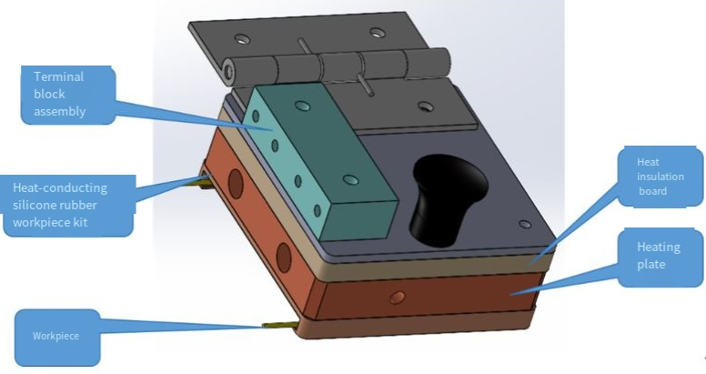
The base has more than 20 channels of independent temperature control function (25-100 degrees), and multi-channel monitoring of the temperature function on the back of the module, and the real-time feedback of the chip thermocouple ensures that the temperature on the back of the module remains stable, and the handle design can be taken independently at any time without interfering with each other.
Model | Multi-channel (perovskite or stacked) DC-PS/PT | Single channel (crystalline silicon or stackup)  SC-SS/PT | Single-channel perovskites  SC-PS
Multi-channel test base | 4/8/20 channels within 50mm | 156/182/210mm | 300mm
Temperature control range | Each channel is independently controlled at 25-100°C (±2°C) with temperature feedback
Temperature monitoring accuracy | 0.1°C
Temperature curve display | It can be displayed and saved in real time

Software testing systems
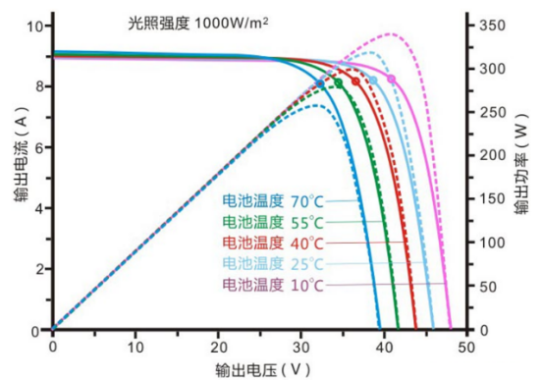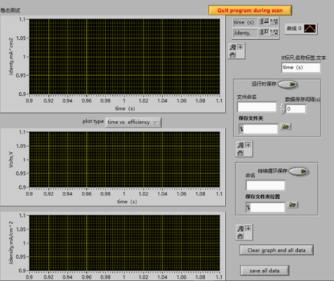
The equipment software is independently developed by Lecheng Intelligence, based on strong equipment integration capabilities, and the company can carry out various customized designs according to customer needs when the hardware configuration meets the conditions.
The main functions of the software system include multi-channel I-V testing, which can realize automatic continuous scanning and interval time testing, and each channel is controlled independently; Multi-channel MPPT testing, multi-channel temperature curve monitoring, timing test and timing save function, and the small device unit can automatically inspect and test a single pixcel point.
Model | Multi-channel (perovskite or stacked) DC-PS/PT | Single channel (crystalline silicon or stackup)  SC-SS/PT | Single-channel perovskites  SC-PS
I-V test mode | forward and reverse scanning test; 9 points are proposed to be legal; Dynamic IV
MPPT tracking algorithm | disturbance observation method; conductance increment method; Fixed voltage method
Monitor data types | Voc、Isc、FF、PCE、Pmax、Imax、Vmax、Rs、Rsh
Data storage | automatic naming and scheduled saving; Each channel is saved independently or unified
Temperature curve display | It can be displayed and saved in real time
Multi-channel control | Each channel has independent start and stop, independent control of parameters, and independent control of temperature

other
project | illustrate
Cooling | Air cooling is used to control the ambient temperature
Humidity control | A humidity control module can be added to control the humidity in the test area
dustproof | Seamless contact is used to isolate dust influences

Factory needs
power supply | 220 V AC、50 Hz、10 A
Device size | 1200×800×1800mm
Ambient temperature | 22 – 27℃
Ambient humidity | 20% — 80%

Annex related

Documentation
When the equipment is delivered, the list of accompanying materials is as follows:
serial number | Name of the data | Quantity (servings)
1 | Cargo packing list | 1
2 | Equipment instruction manual | 1

Amenities
For the key components of the equipment, Lecheng has built a spare parts warehouse, which can be replaced if there is a major failure on site, the list is as follows:
name | Model specifications
Multi-channel temperature control module
Multi-channel test module
Substrate fixtures

Consumables
Commonly used consumables for equipment are as follows:
name | Replacement cycle
terminal blocks | 1 year
Heating plates | 1 year

Service description:

Installation and commissioning
According to the contract, the company safely transports the equipment to the installation location designated by the user within the specified time, and sends technical service engineers to install it on site. In the case that the user has basic installation and debugging spare parts, the technical service engineer will complete the installation and debugging of the equipment for the user to use within 3 working days to ensure that the installation and commissioning site environment is neat, clean and orderly.

After-sales training
After the equipment is debugged, the company conducts no less than 1 day of technical training for user operators, and the main training content is as follows:
- Multi-channel test software usage training;
- Multi-channel test platform operating specifications;
- training on and off operating procedures;
- the significance of panel and software control parameters, training on the range of parameter selection;
- basic cleaning treatment and maintenance of the machine;
- Common hardware fault handling and operation issues that should be paid attention to.

Equipment maintenance
From the date of acceptance of the equipment, Lecheng equipment provides a free warranty period of twelve months for the whole machine, and provides lifelong maintenance services.
During the warranty period, after-sales personnel will be arranged to arrive at the customer's site every three months to inspect the equipment, provide basic maintenance of the equipment and give relevant usage opinions.
If the equipment fails, the after-sales response time during the warranty period is within 24 hours, and the user engineering personnel will be given remote guidance as soon as possible through telephone, video, etc.; For emergency faults that cannot be solved on-site by user engineering personnel, the company's maintenance personnel will arrive at the site to solve them within 72 hours; The maintenance of equipment outside the warranty period shall be agreed separately by both parties.

